MINI PROJECT

User Interface Design

E-Ration Shop

Soorya P

Integrated MCA S9

Rollno: 50

**User Interface Design**

**Landing Page:**

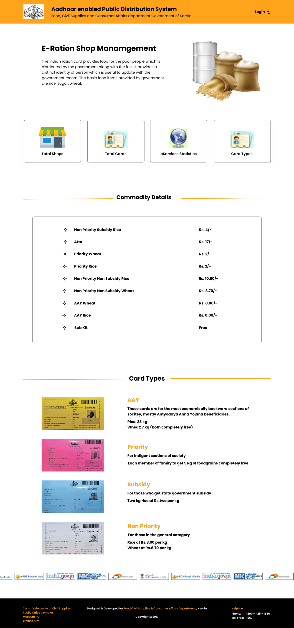

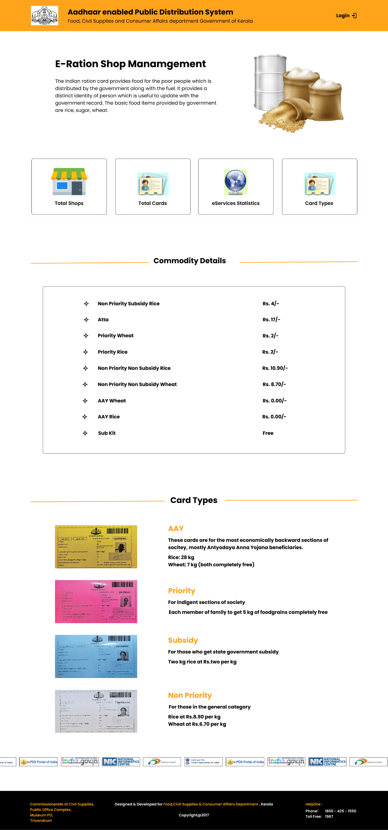

**Login Page Design:**

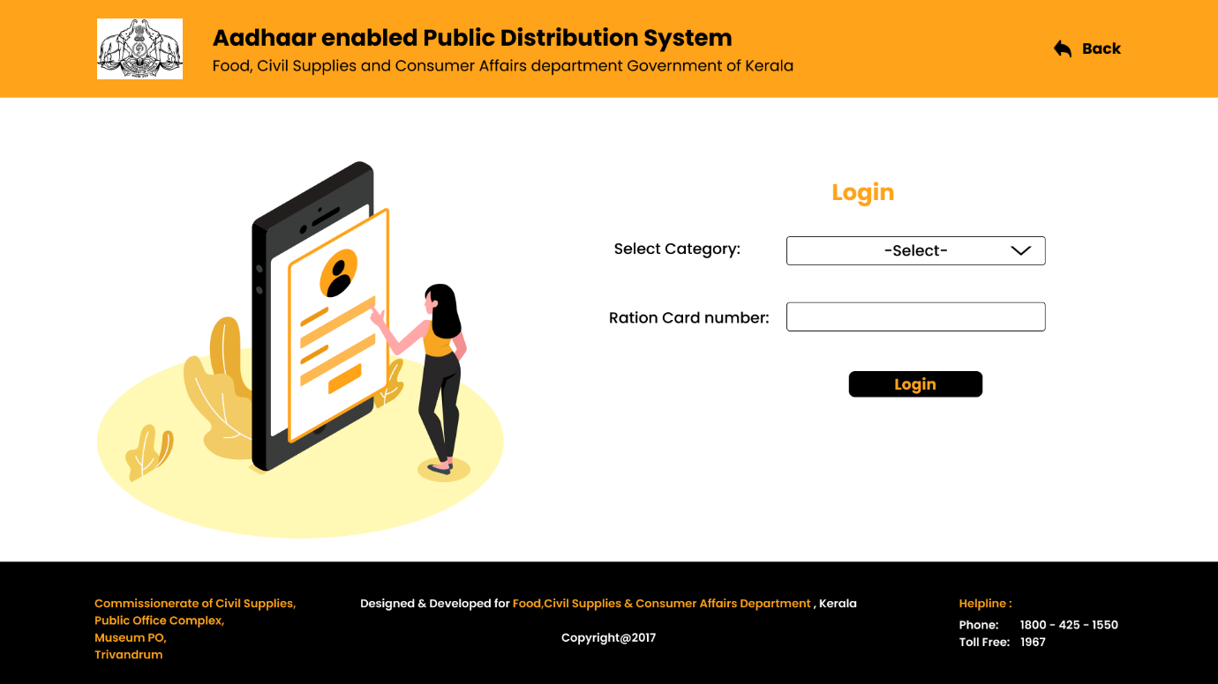

Choose a category from the dropdown menu, which includes customer, government administrator, shop administrator, and supplier.

* **Customer Login Page Design:**

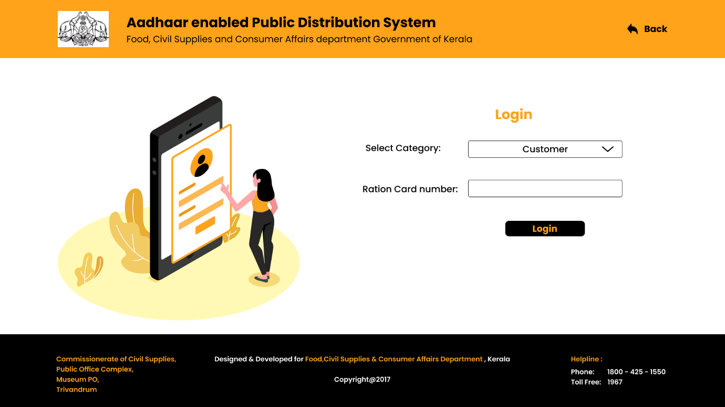

Customers must input their ration card number in order to log in.

* **Supplier Login Page Design:**

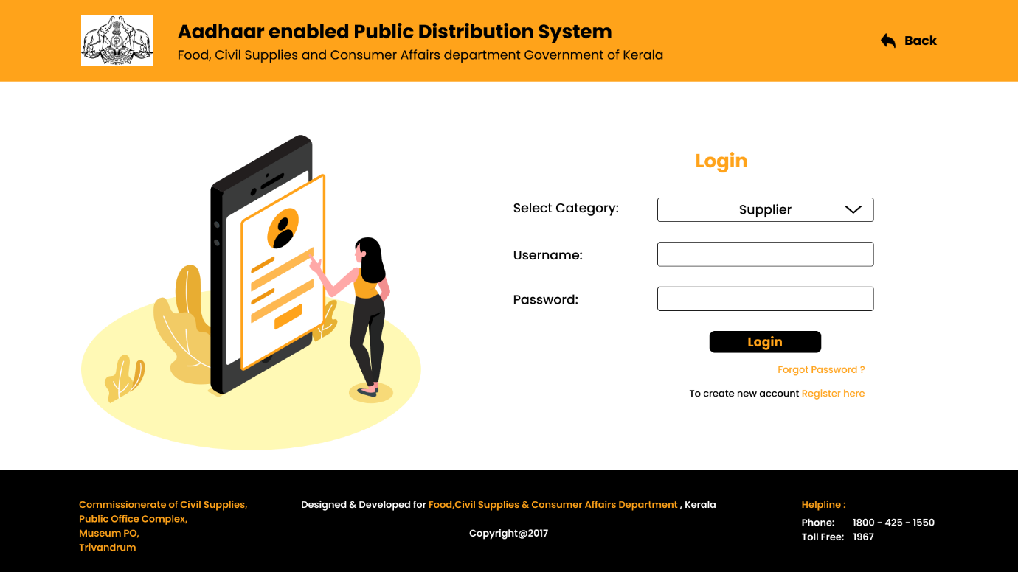

To login, suppliers must input their username and desired password.

* **Government Admin Login Page Design:**

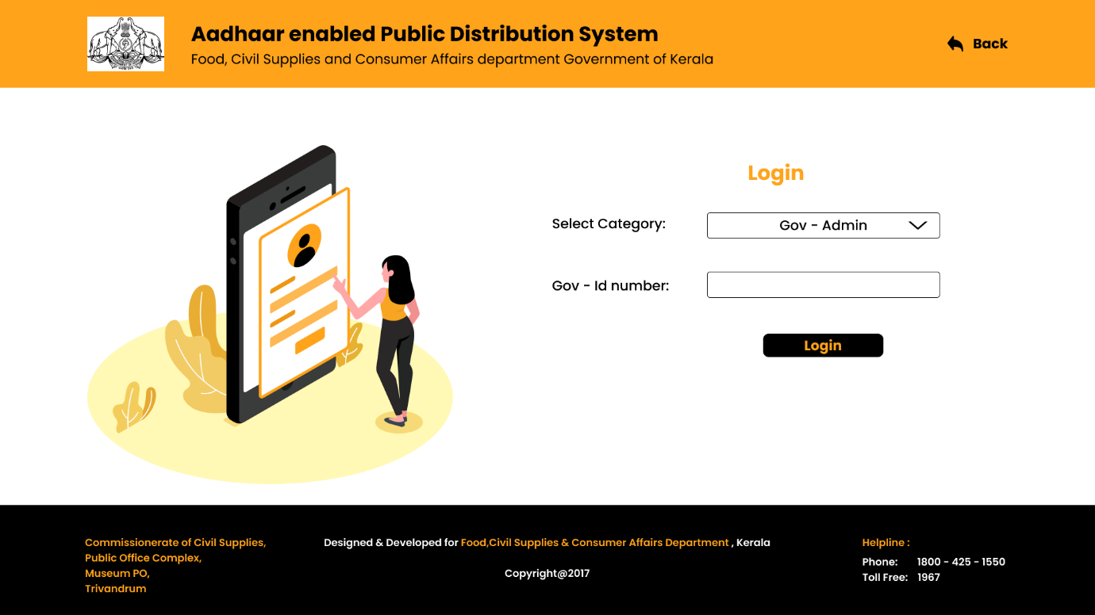

To log in, the government administrator needs a desired id. The government administration is already aware of it.

* **Ration Shop Admin Login Page Design:**

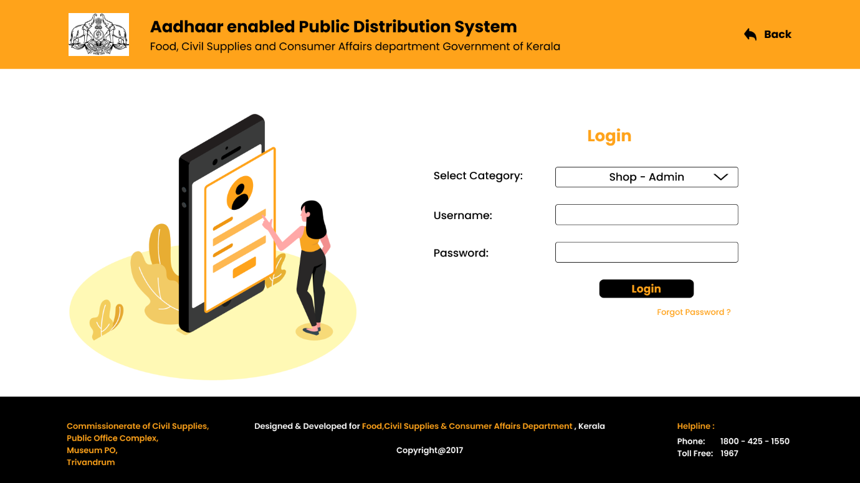

To log in, ration store managers must use the username and password provided by the government.

**Customer Page Design:**

* **Customer Landing Page Design:**

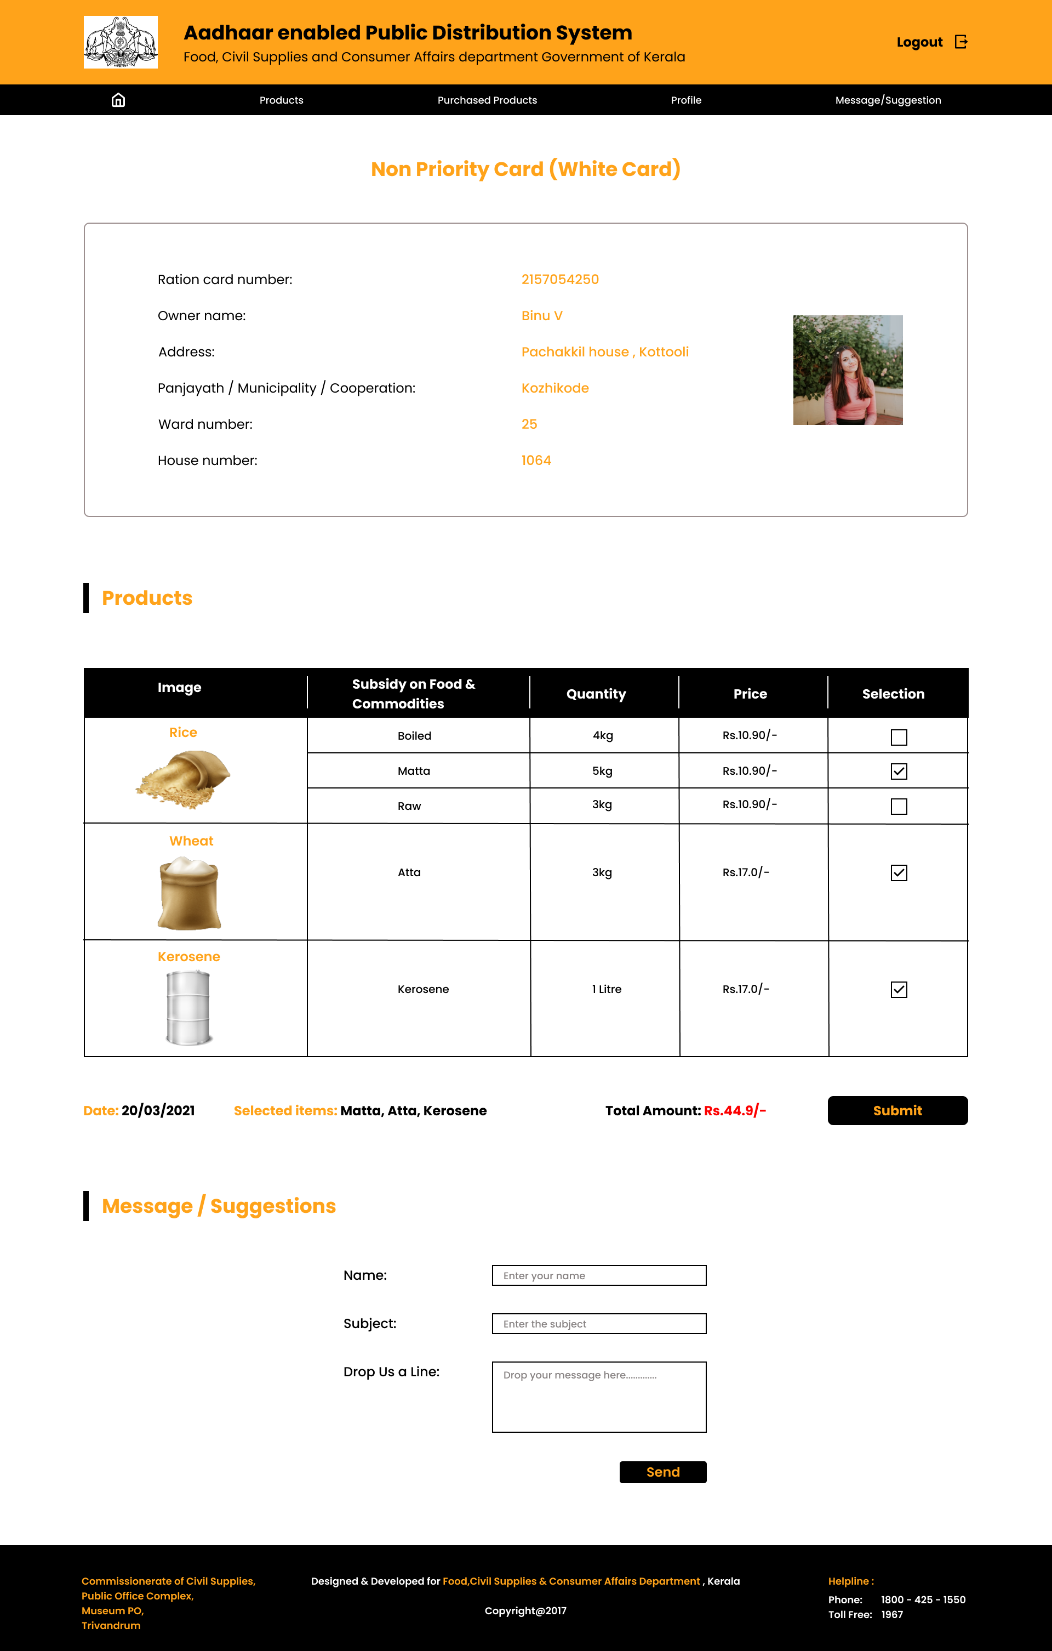



Each card kind has its own set of products. Customers can choose their desired goods from the Products area. The entire money and selected items will be presented below the table, and they must click the submit button to purchase it. It will then take you to the payment page.

Customers can enter any complaints, messages, or recommendations in the message/suggestion section.

* **Design of the Customer Profile Page:**

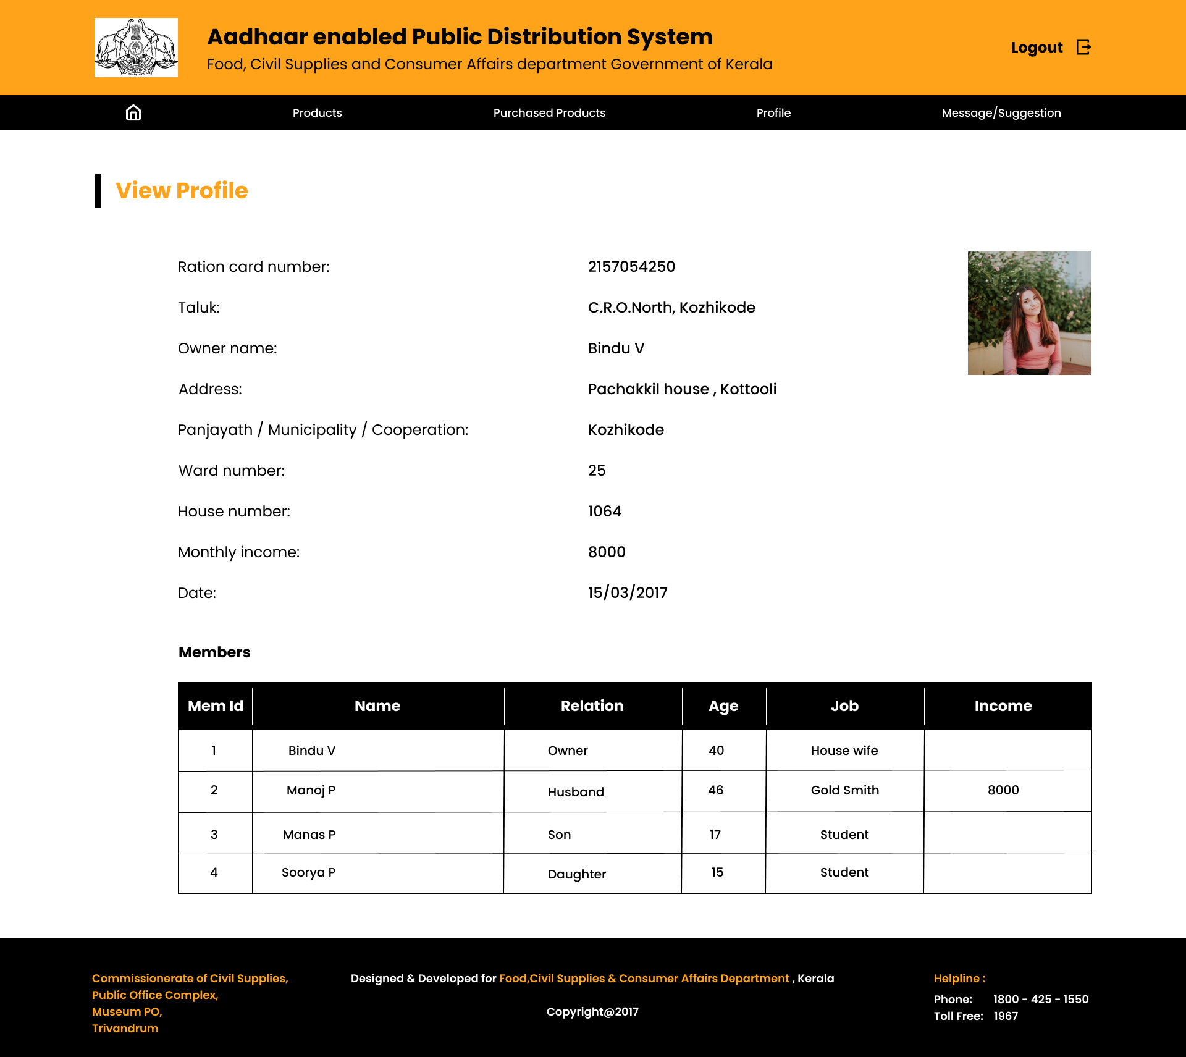

* **Design of the Customer Purchase Products List Page:**

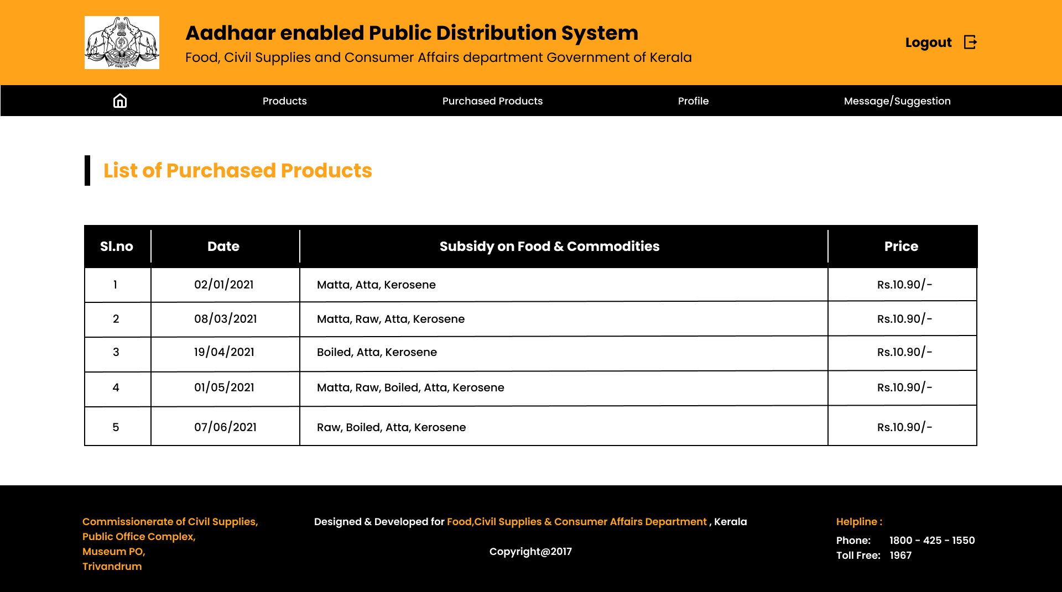

**Delivery Team’s Page Design:**

* **Form for registering suppliers:**

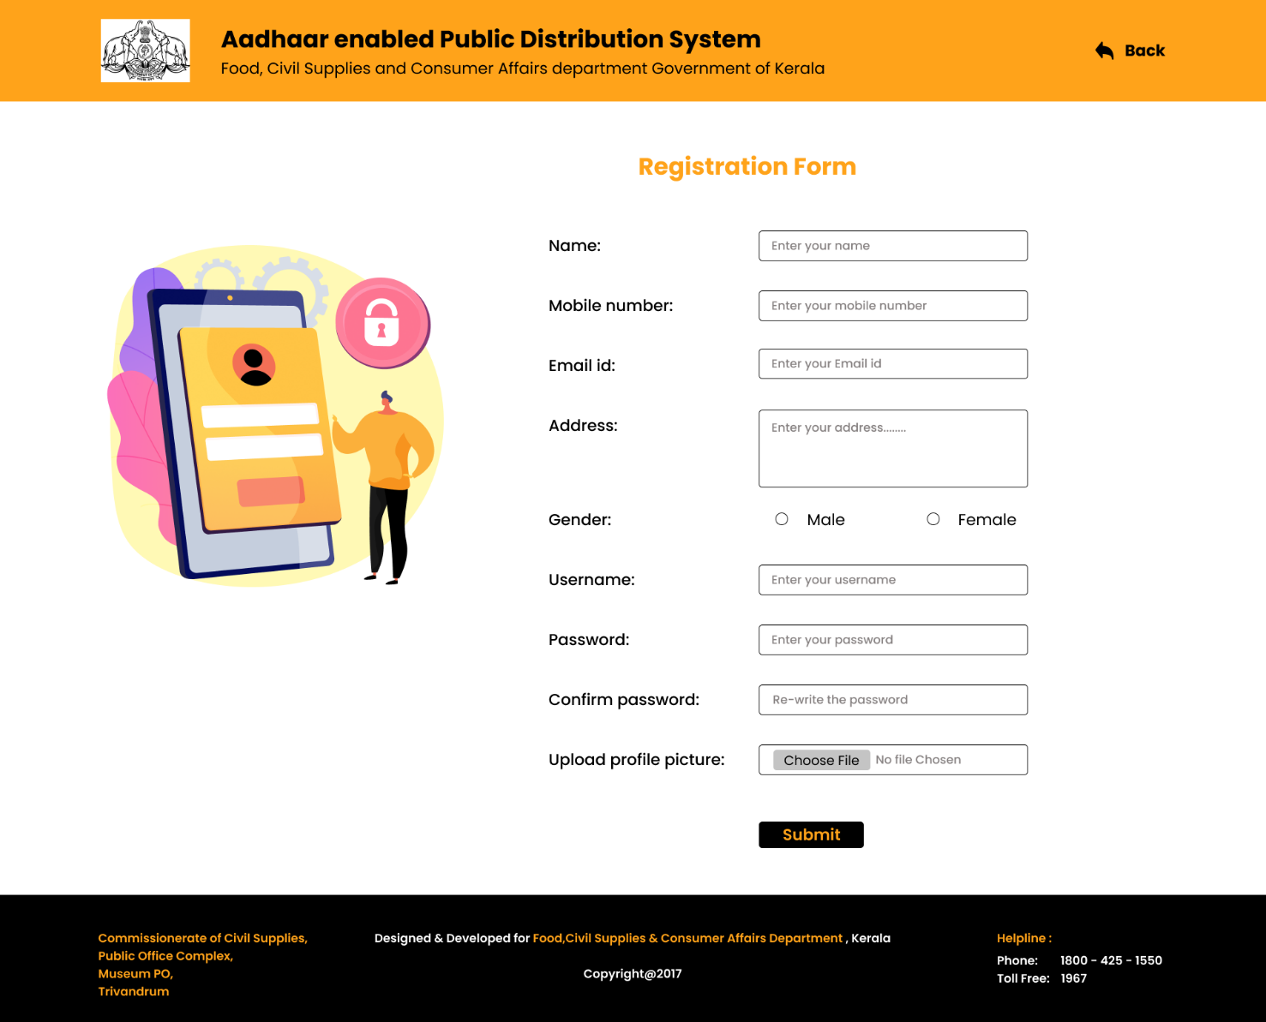

The supplier must register their information. And then you'll have to wait for their permission notice before you can join the delivery crew. They will be able to log in to the site once they have been approved.

* **Landing page design for each delivery member:**

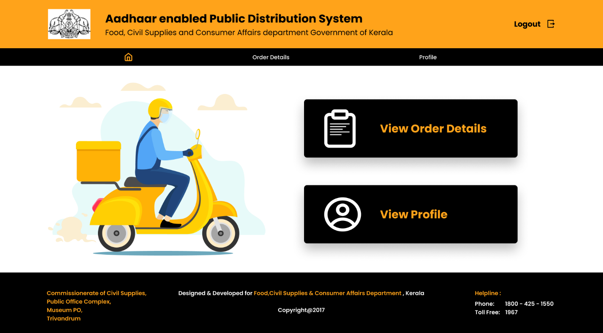

* **View order details page design:**

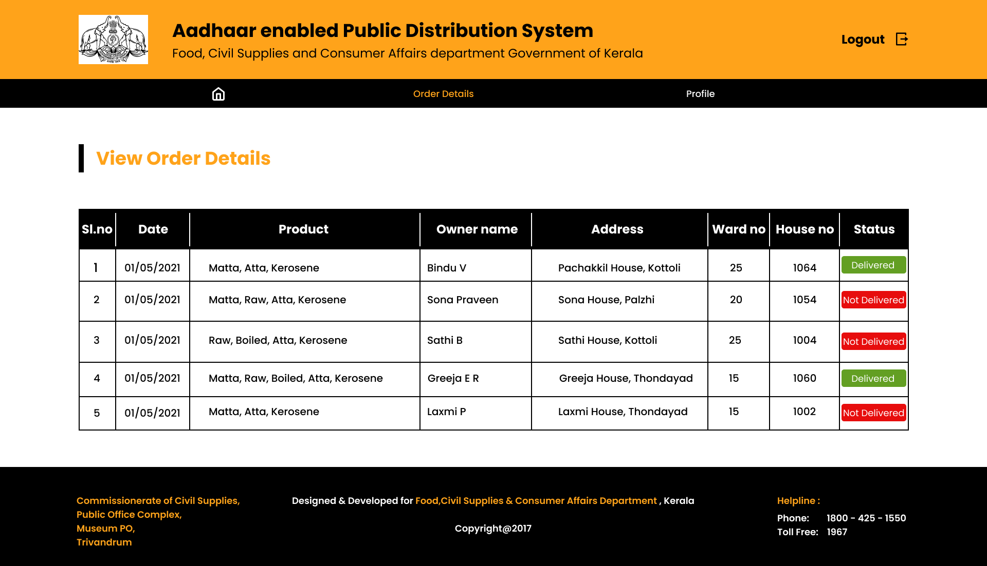

The member of the delivery crew has access to the customer's order information. So that they can deliver the ordered goods to the customer's residence. The table's status section displays the current status of the ordered details, including whether they have been delivered or not. The delivery team member must update the status after each delivery by clicking the button in the status column.

* **Design of the Delivery boy’s Profile Page:**

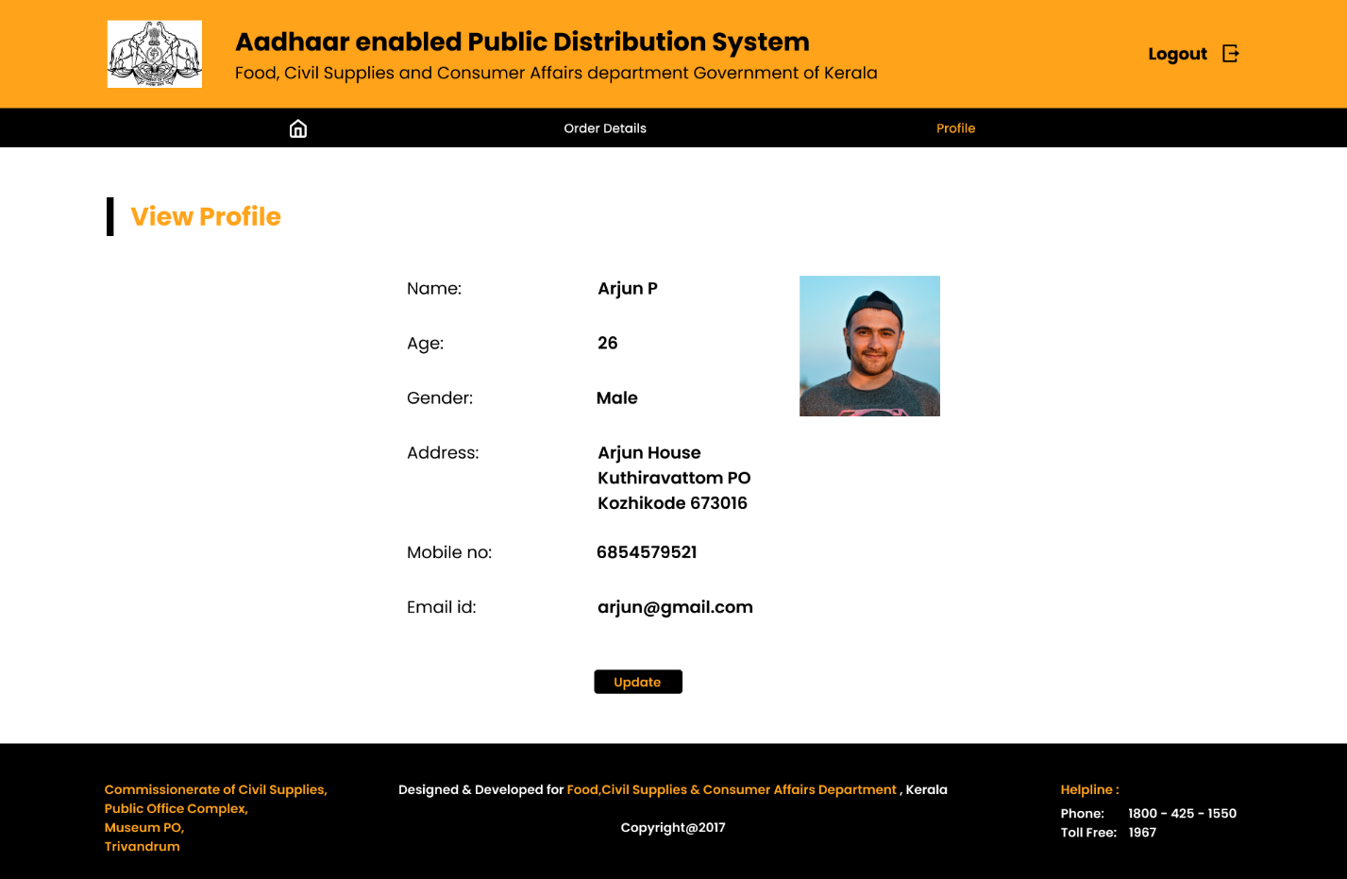

The user can read their profile here and update it if anything changes.

**Government Admin Page Design:**

* **Government Admin Landing Page Design:**

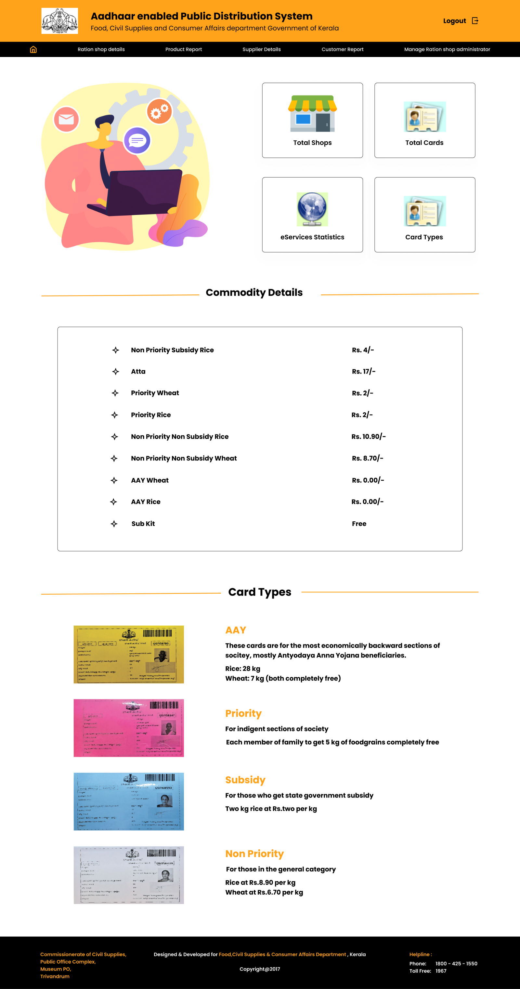

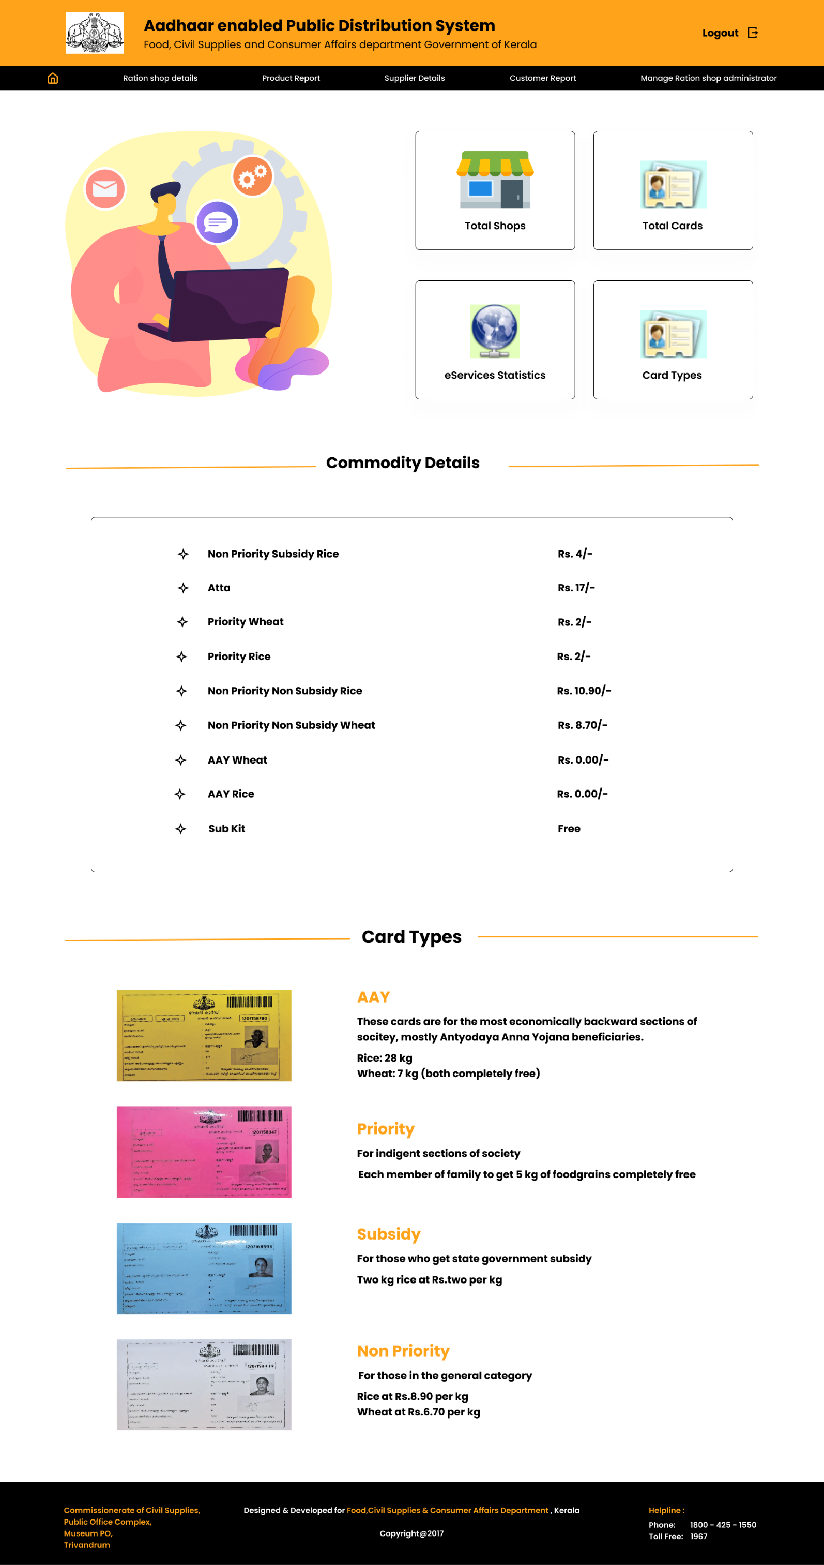

* **Design of the Ration Shop Details Page:**

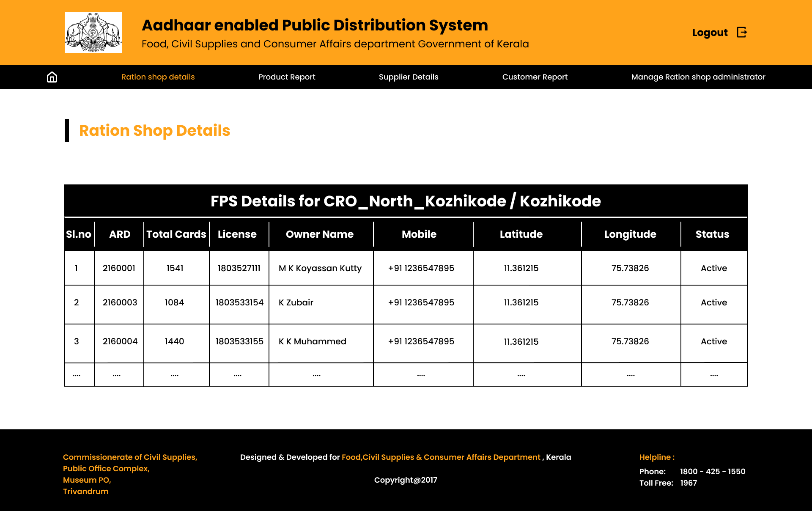

* **Design of the Product report page:**

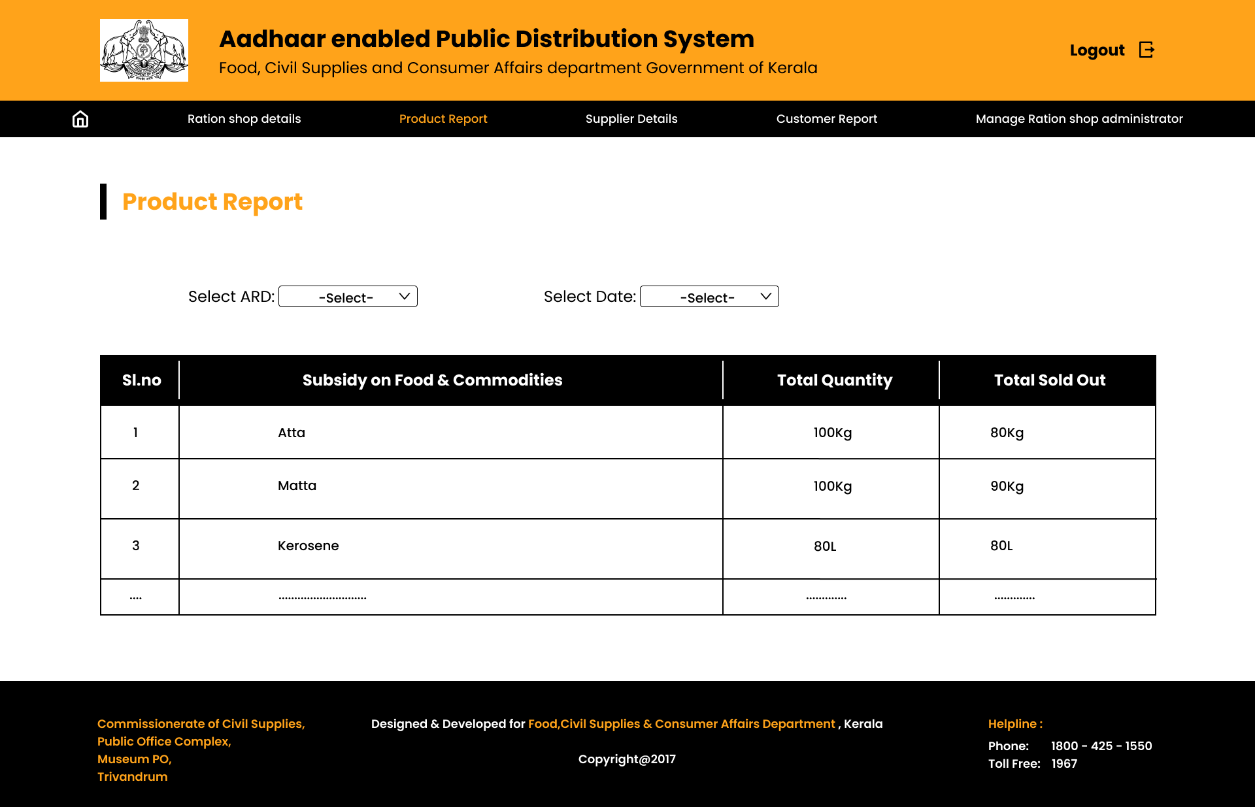

To view a product report, the admin must first select the ARD number and then the date from the dropdown menus.

* **Design of the supplier information page:**

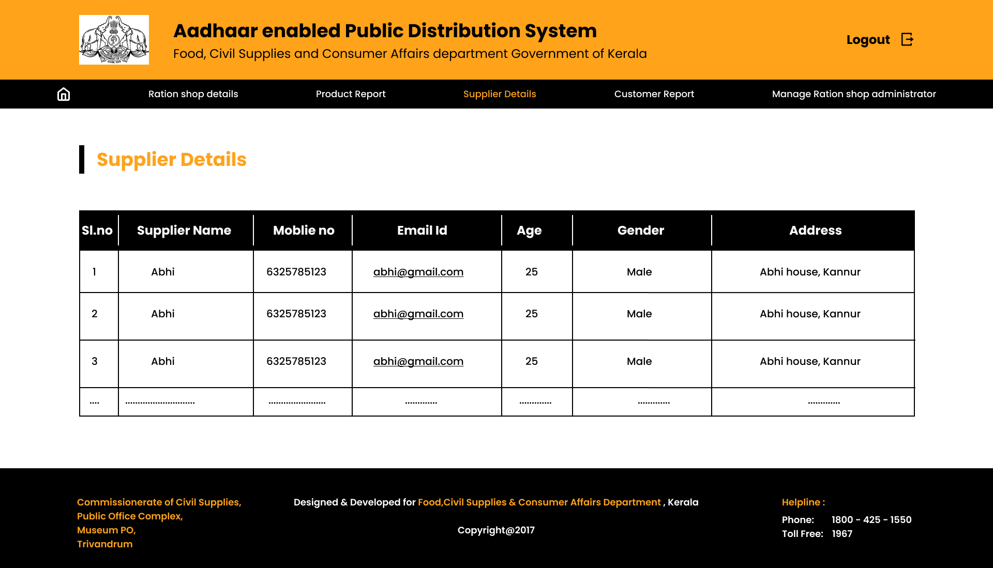

* **Design of the customer report page:**

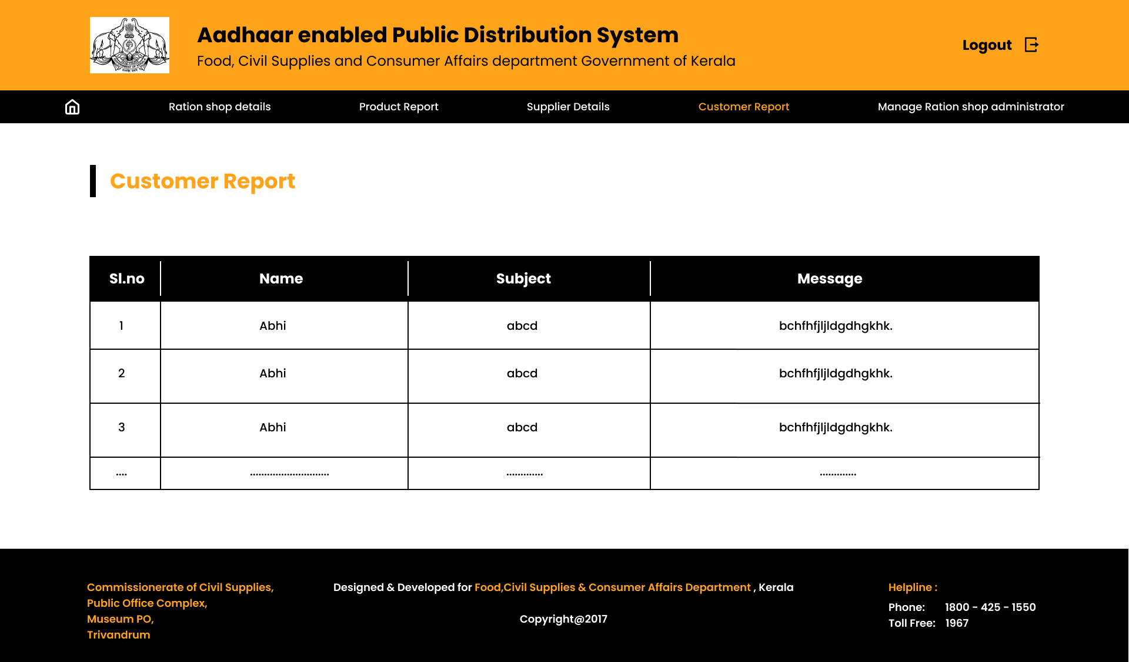

* **Design of the ration shop administrator page:**
  + **Form for registering ration shop administrator:**

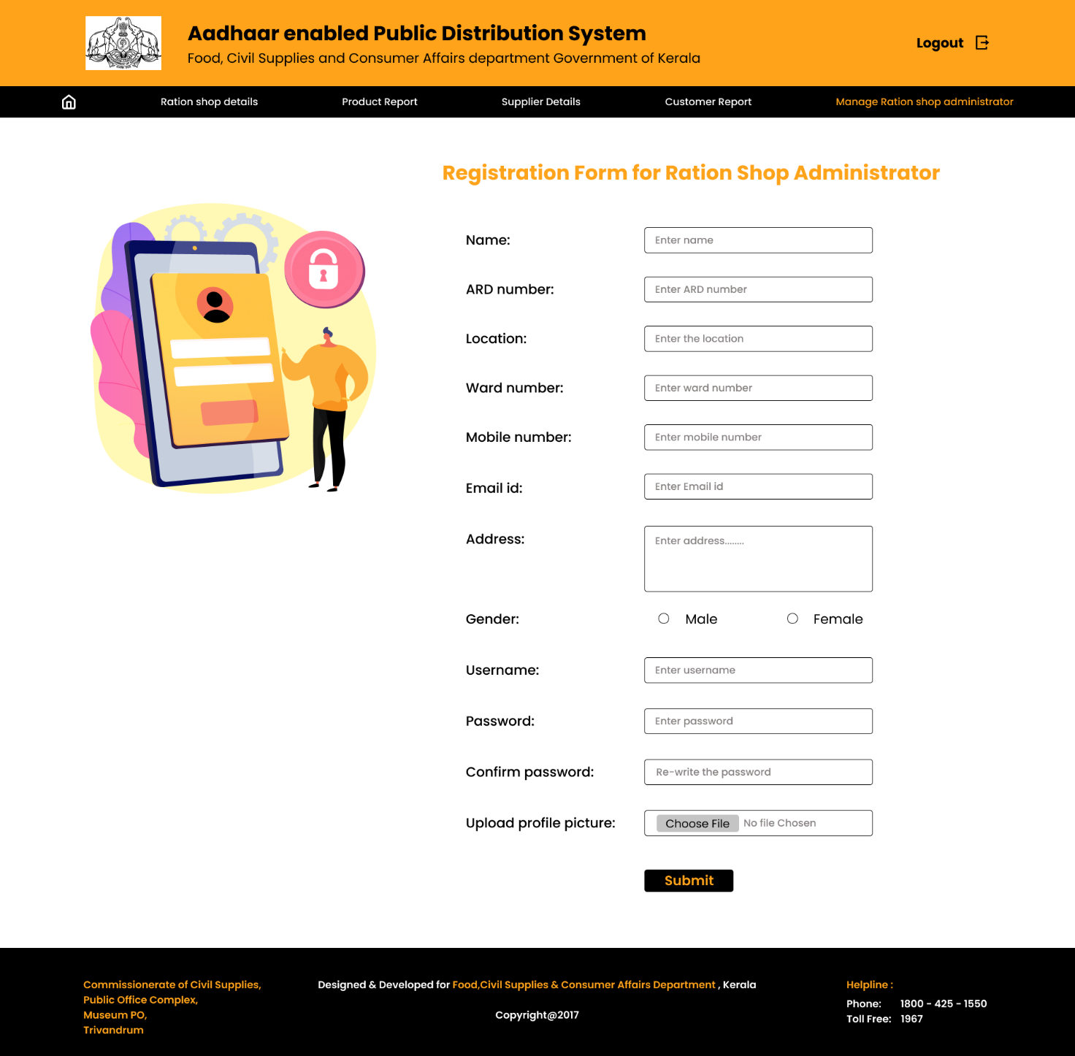

* + **View ration shop administrator details:**

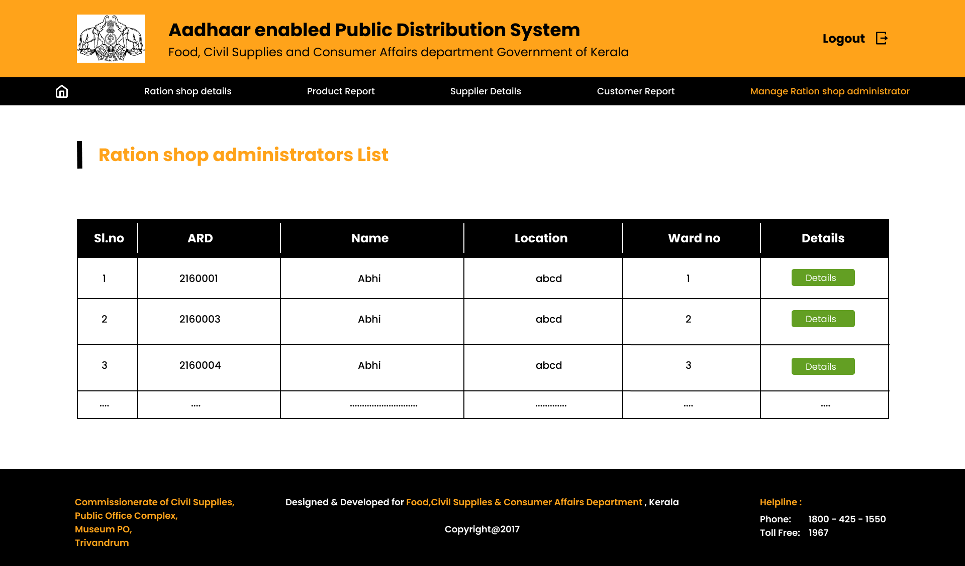

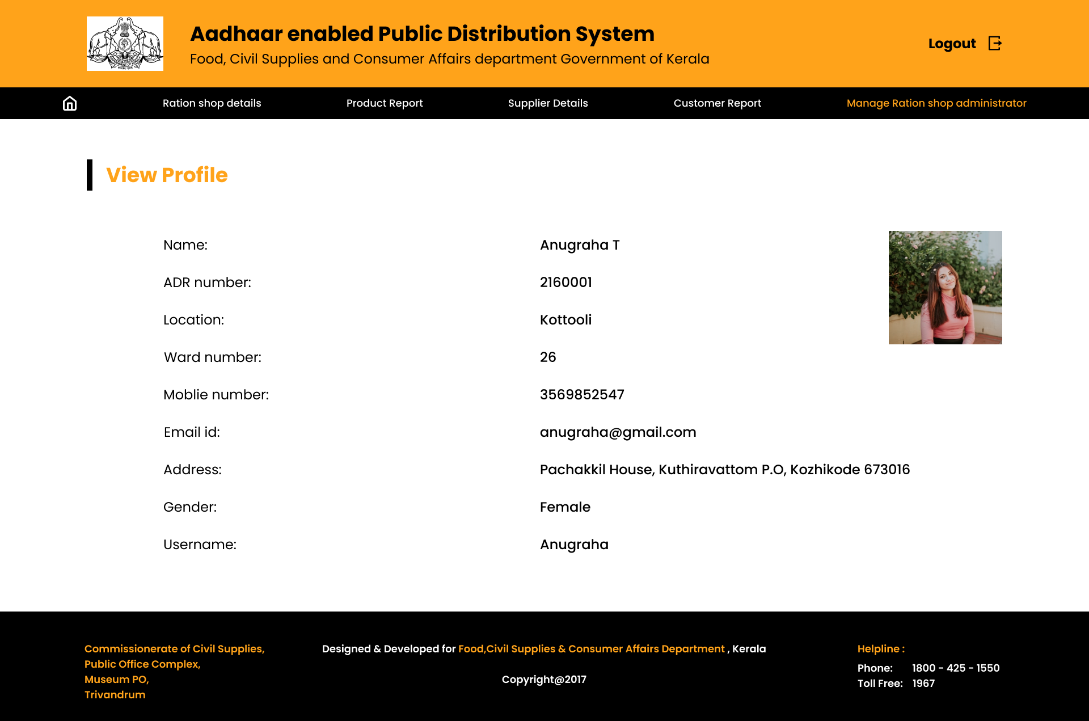

**Ration Shop Admin Page Design:**

* **Ration Shop Admin Landing Page Design:**

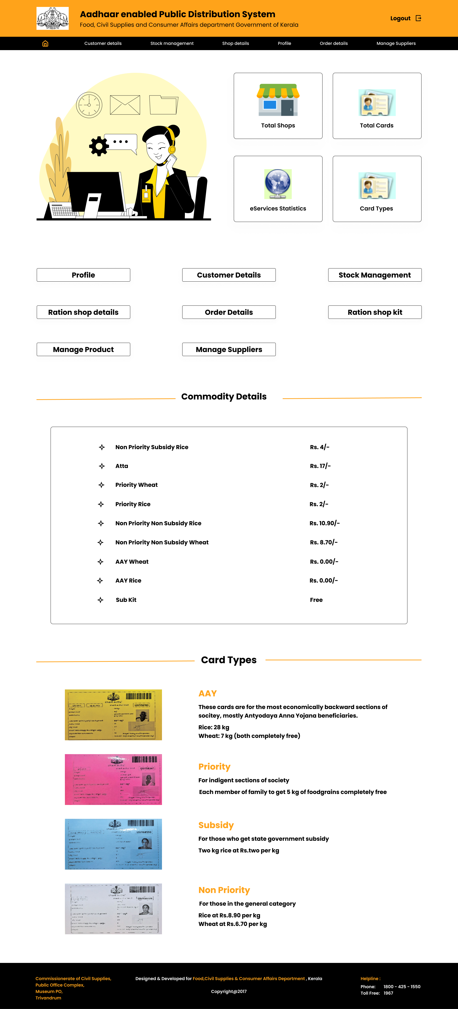



* **Design of Ration Shop Admin Profile Page:**

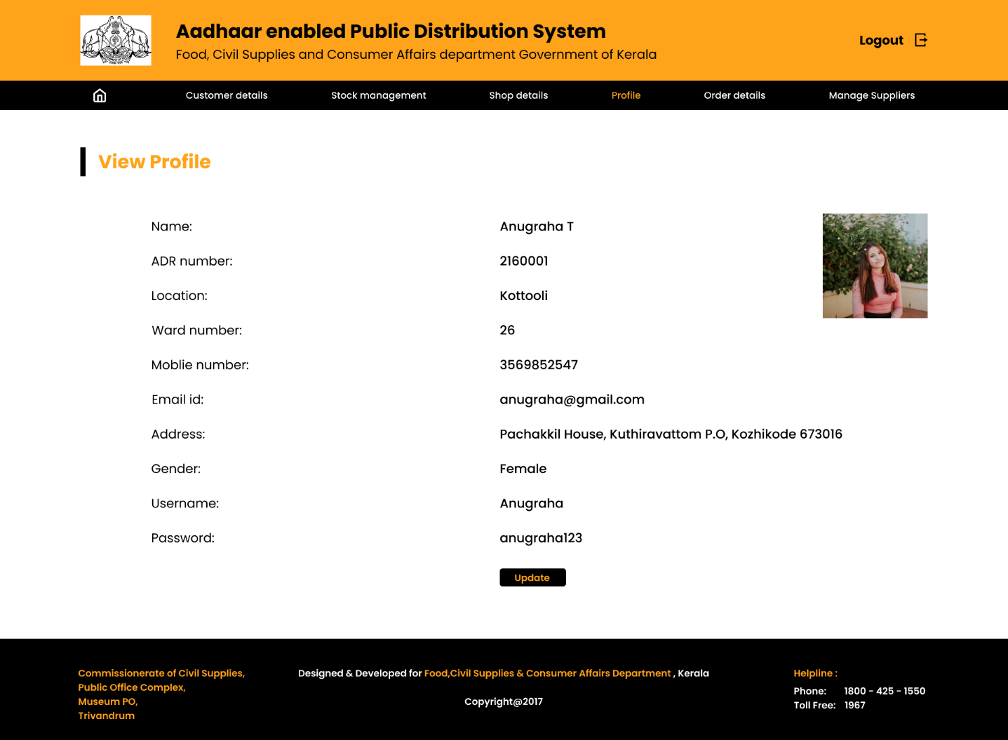

* **Design of Customer details page:**

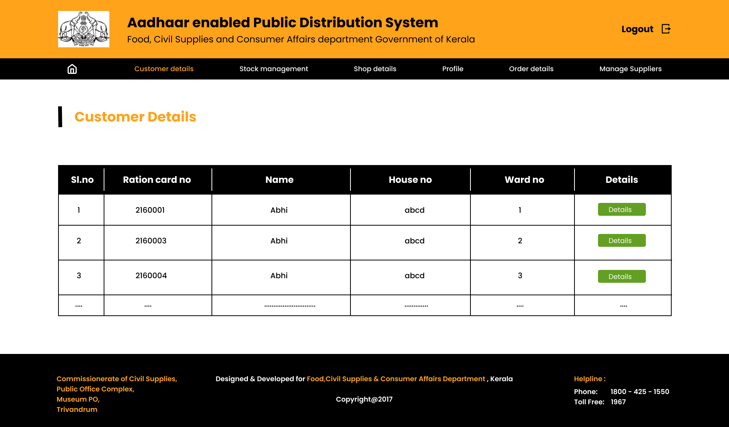

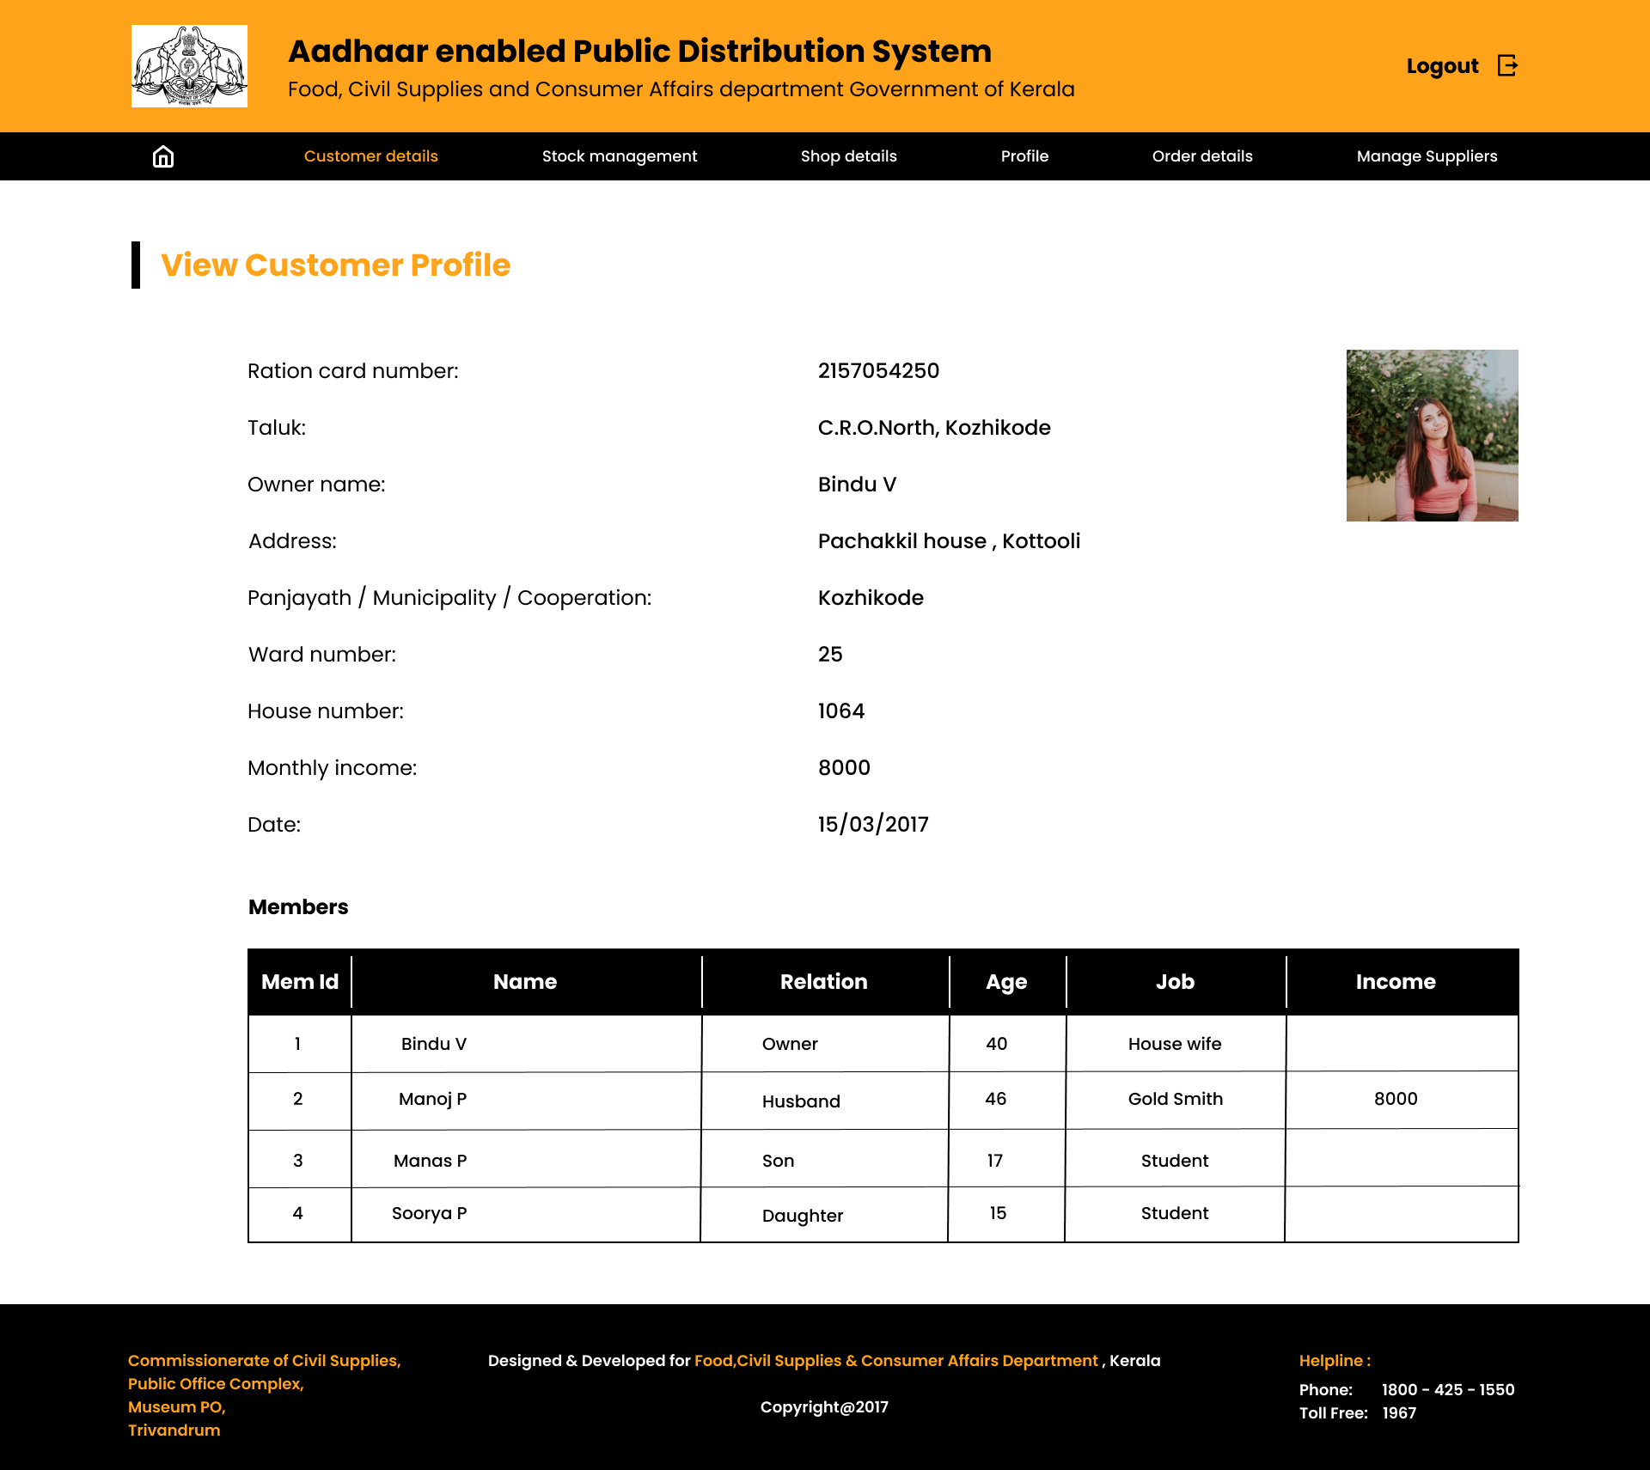

* **Design of Stock management page:**
  + **Design of add stock details page:**

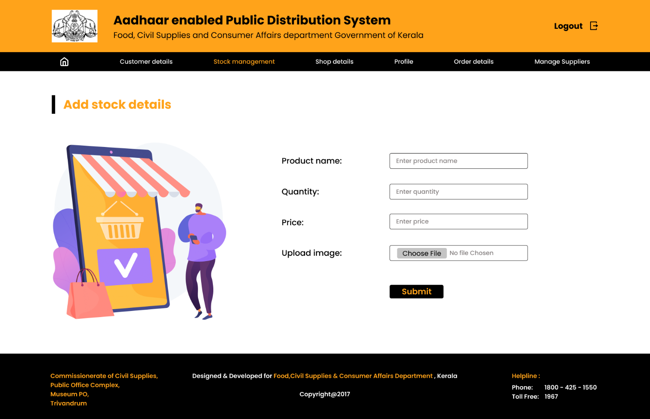

* + **Design of View stock details page:**

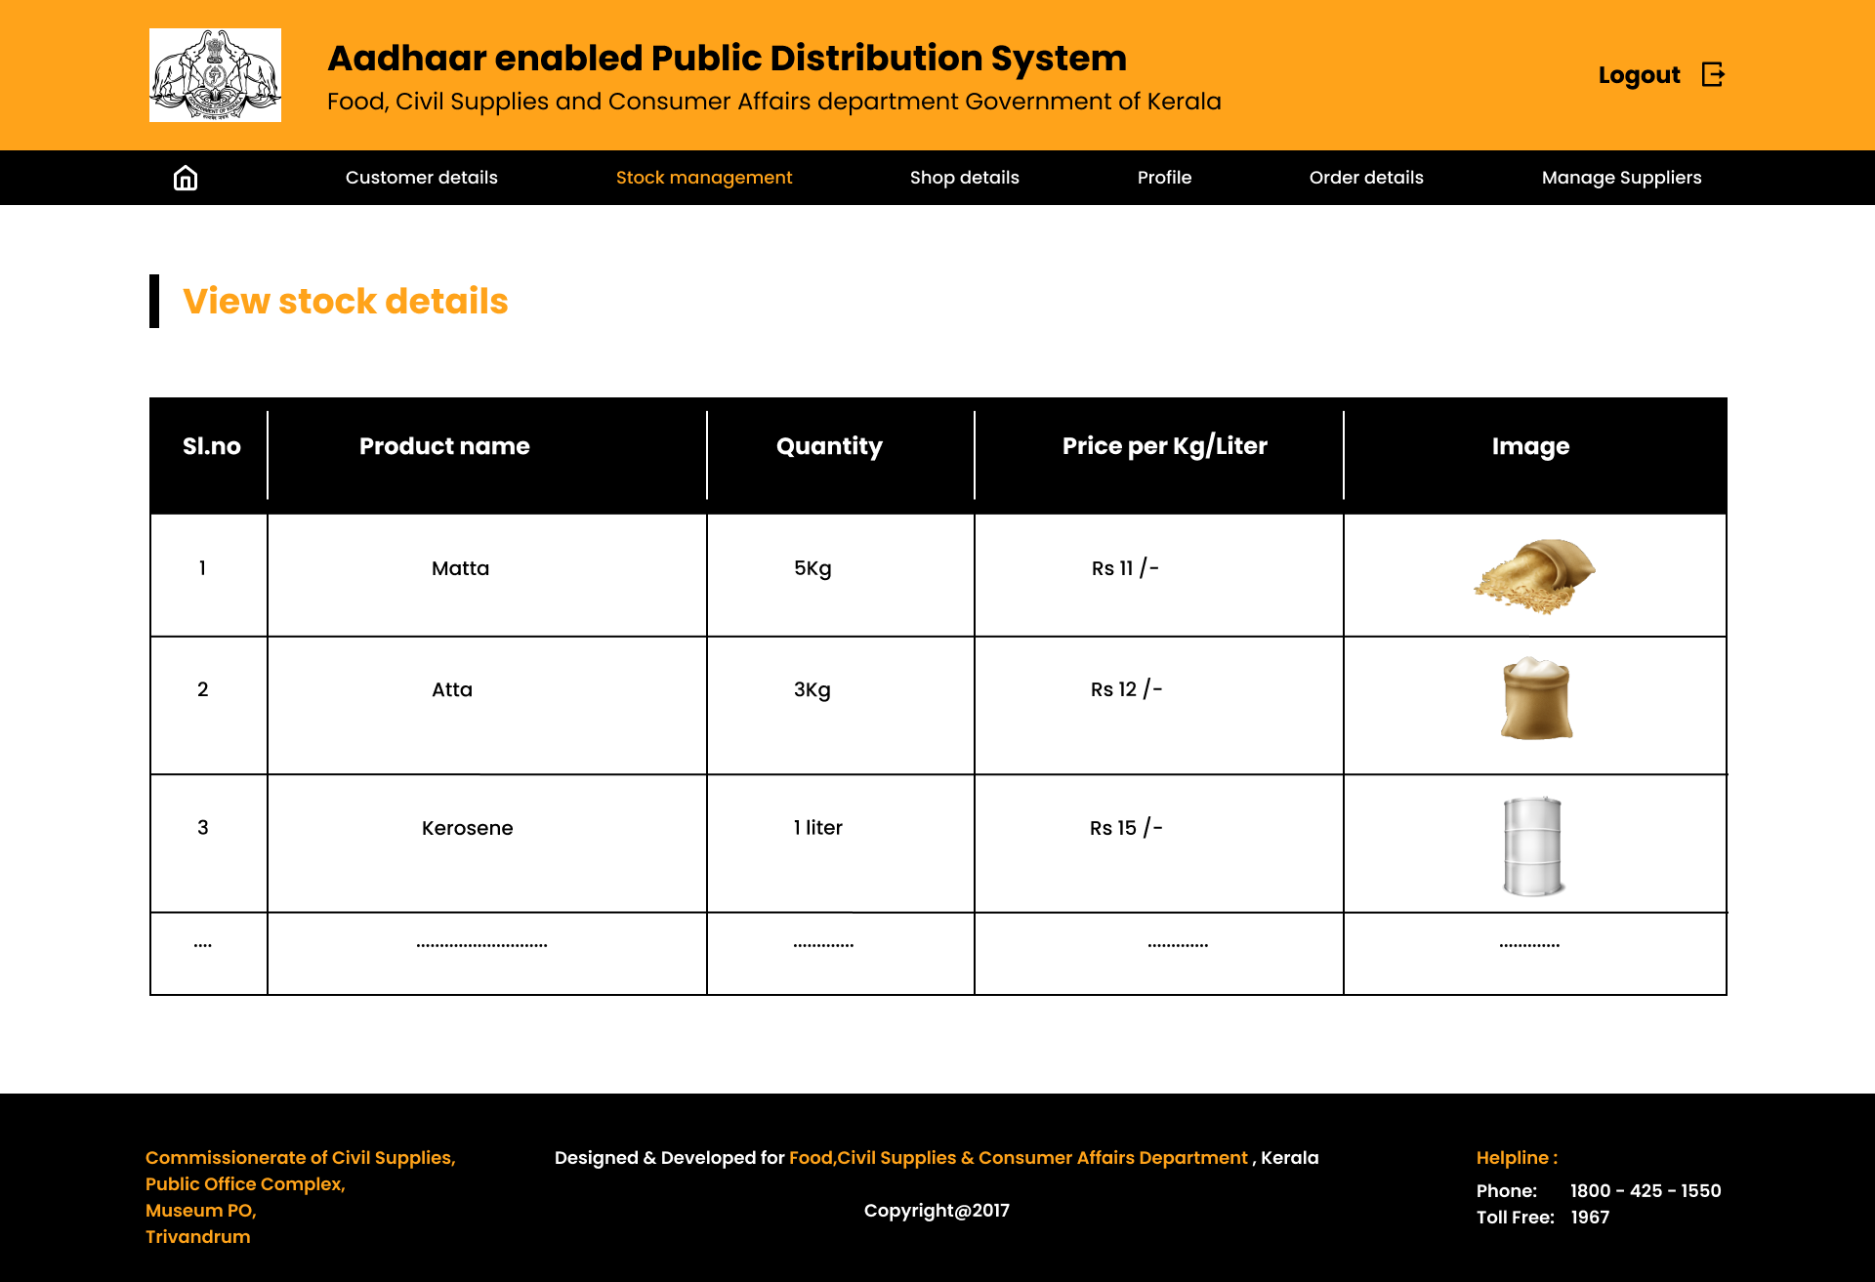

* + **Design of add ration kit information page:**

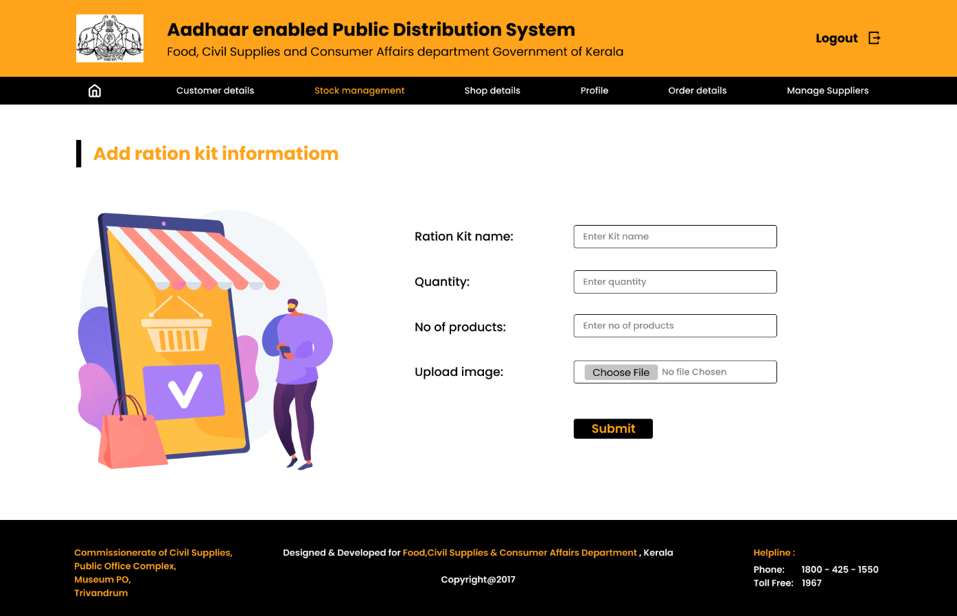

* + **Design of view ration shop kit information page:**

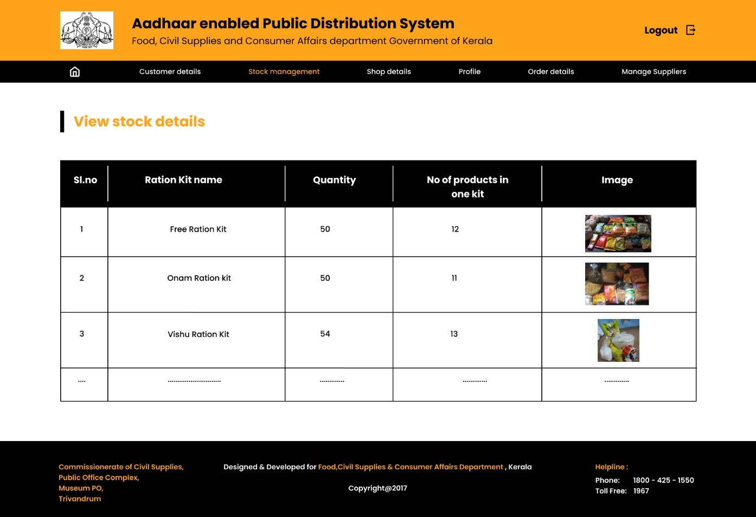

* + **Design of view ration shop kit information page:**

